ДОМАШНЕЕ ЗАДАНИЕ
ПО ДИСЦИПЛИНЕ «ОПЕРАЦИОННЫЕ СИСТЕМЫ И СРЕДЫ»
ТЕМА: Практика по простым командам 2
Студент: Вобленко Глеб Владимирович
Группа: РПО 26/1
Срок сдачи: 23.09.2026
Преподаватель: Штейнберг Эмиль Эдуардович

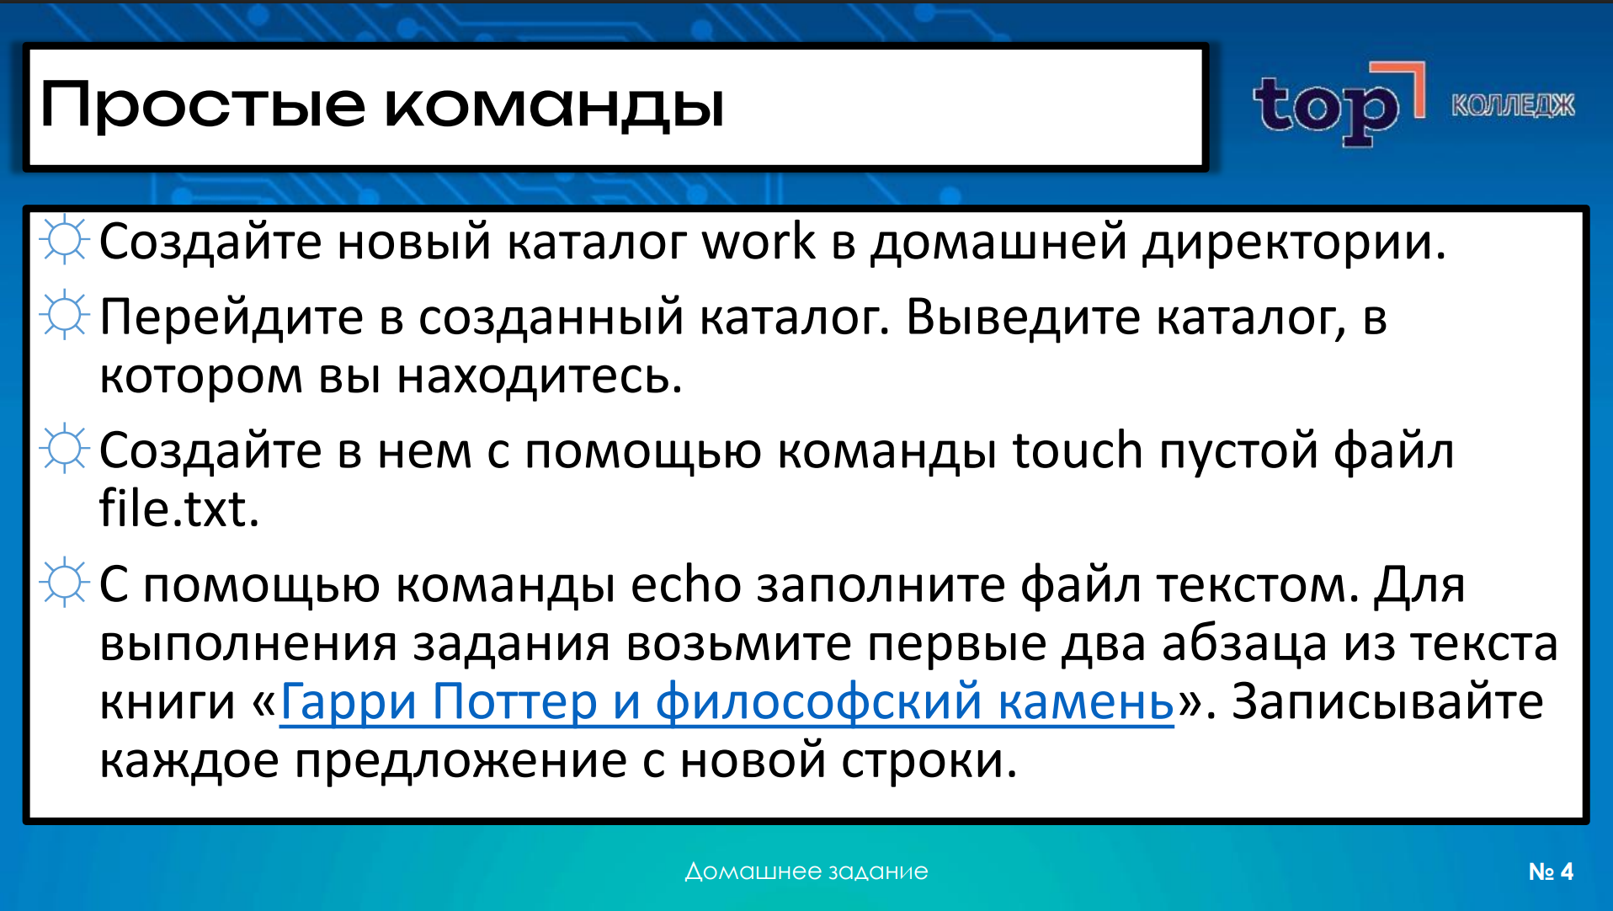
Задание 1 mkdir ~/work
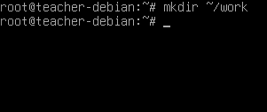
Задание 2 cd ~/work && pwd
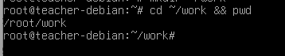
Задание 3 touch file.txt
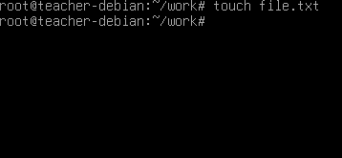
Задание 4
echo -e "\nMr and Mrs Dursley, of number four, Privet Drive, were proud to say that they were perfectly normal, thank you very much.\nThey were the last people you’d expect to be involved in anything strange or mysterious, because they just didn’t hold with such nonsense.\n\nMr Dursley was the director of a firm called Grunnings, which made drills.\nHe was a big, beefy man with hardly any neck, although he did have a very large moustache.\nMrs Dursley was thin and blonde and had nearly twice the usual amount of neck, which came in very useful as she spent so much of her time craning over garden fences, spying on the neighbours.\nThe Dursleys had a small son called Dudley and in their opinion there was no finer boy anywhere.\n" > file.txt
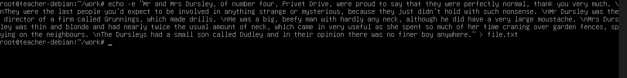
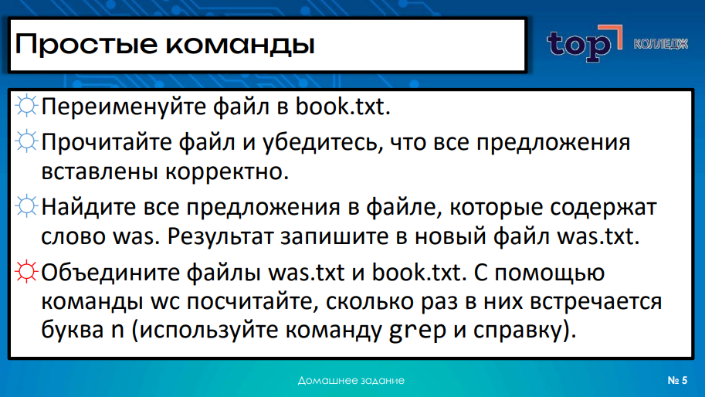
Задание 1 mv file.txt book.txt
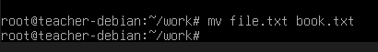
Задание 2 cat book.txt
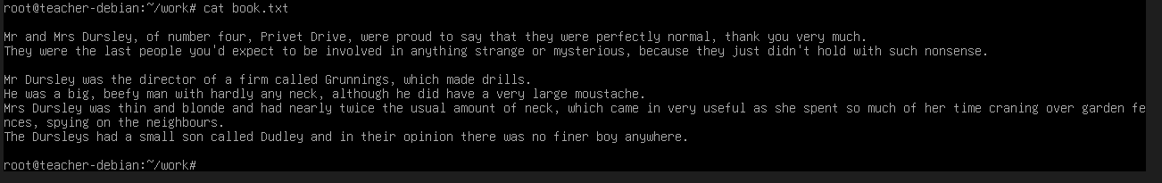
Задание 3 grep “was” book.txt > was.txt
Задание 4 cat was.txt book.txt | grep -io “n” | wc -l
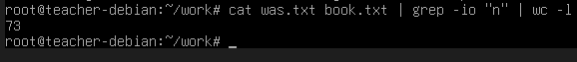
Вывод: В ходе выполнения данного домашнего задания я научился создавать и переименовывать каталоги и файлы, работать с текстовым содержимым с помощью команды echo, а также освоил базовые инструменты фильтрации и анализа данных с использованием grep и wc.

